Spherical Sector
# Source: AI Source: Provided by: [Data Path: Persons Table -> ID Column: 1, Name_En Column: Motasem Essam] -> From: [ChatGPT] on [7/25/2026]
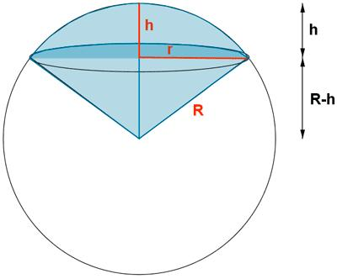

Definition
# Source: AI Source: Provided by: [Data Path: Persons Table -> ID Column: 1, Name_En Column: Motasem Essam] -> From: [ChatGPT] on [7/25/2026]
A spherical sector is a solid region of a sphere bounded by a spherical cap and the conical surface formed by joining the boundary of the cap's circular base to the center of the sphere.
It can be thought of as the solid formed by taking a spherical cap and adding the cone-shaped region between its base and the sphere's center.

Simple Definition
# Source: AI Source: Provided by: [Data Path: Persons Table -> ID Column: 1, Name_En Column: Motasem Essam] -> From: [ChatGPT] on [7/25/2026]
A spherical sector is a portion of a sphere shaped like a rounded wedge, consisting of a spherical cap and a cone that share a circular base.

Types of Spherical Sectors
# Source: AI Source: Provided by: [Data Path: Persons Table -> ID Column: 1, Name_En Column: Motasem Essam] -> From: [ChatGPT] on [7/25/2026]
Spherical sectors can be classified by the size and position of their spherical cap.
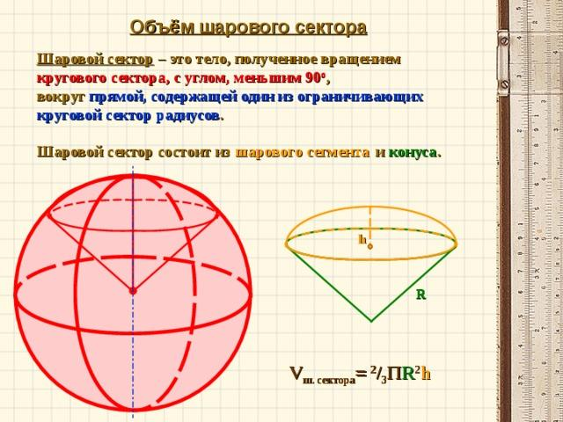

Minor Spherical Sector
# Source: AI Source: Provided by: [Data Path: Persons Table -> ID Column: 1, Name_En Column: Motasem Essam] -> From: [ChatGPT] on [7/25/2026]
A sector formed from a spherical cap whose height is less than the sphere's radius. It occupies less than half of the sphere's volume.
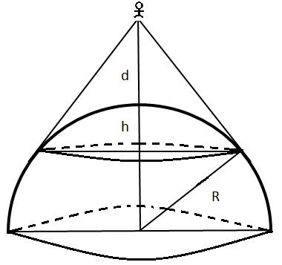

Hemispherical Sector
# Source: AI Source: Provided by: [Data Path: Persons Table -> ID Column: 1, Name_En Column: Motasem Essam] -> From: [ChatGPT] on [7/25/2026]
A special case corresponding to a hemispherical cap. The cap height equals the sphere radius, and the sector occupies half the sphere.
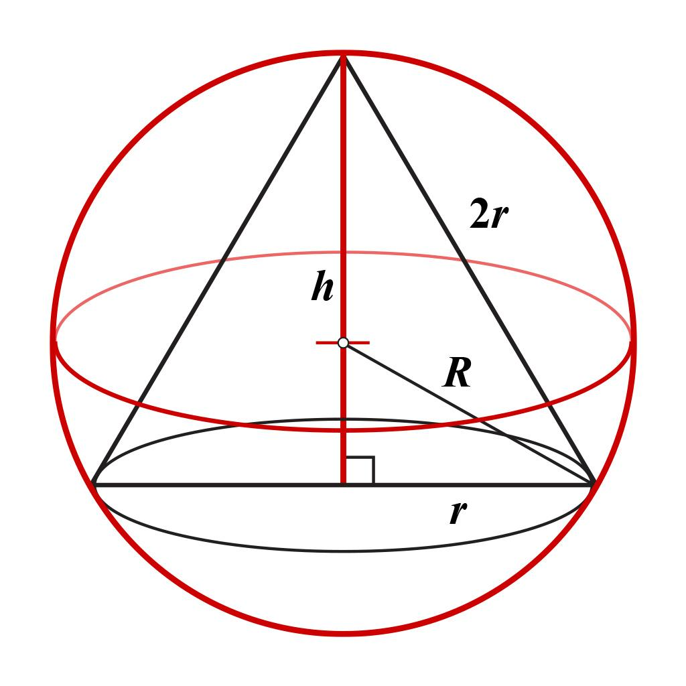

Major Spherical Sector
# Source: AI Source: Provided by: [Data Path: Persons Table -> ID Column: 1, Name_En Column: Motasem Essam] -> From: [ChatGPT] on [7/25/2026]
A sector formed from a spherical cap whose height exceeds the sphere's radius. It occupies more than half of the sphere's volume.
These labels describe sectors by cap size. The standard definition is based on the spherical cap and the cone connecting its circular boundary to the sphere's center.

Main Parts and Symbols
# Source: AI Source: Provided by: [Data Path: Persons Table -> ID Column: 1, Name_En Column: Motasem Essam] -> From: [ChatGPT] on [7/25/2026]
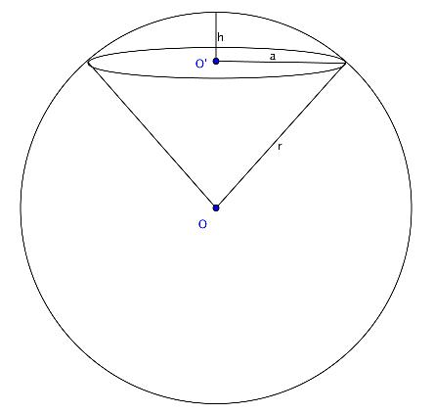
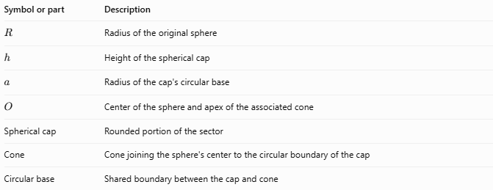
Symbol or part | Description
$$R$$ | Radius of the original sphere
$$h$$ | Height of the spherical cap
$$a$$ | Radius of the cap's circular base
$$O$$ | Center of the sphere and apex of the associated cone
Spherical cap | Rounded portion of the sector
Cone | Cone joining the sphere's center to the circular boundary of the cap
Circular base | Shared boundary between the cap and cone
The cone's height is $R-h$ when the cap is measured from the top of the sphere. This height may be negative as a signed coordinate for a major cap, but the geometric distance is its absolute value.

Mathematical Formulas
# Source: AI Source: Provided by: [Data Path: Persons Table -> ID Column: 1, Name_En Column: Motasem Essam] -> From: [ChatGPT] on [7/25/2026]
Let $R$ be the sphere radius, $h$ the cap height, and $a$ the radius of the cap's circular base.

A. Radius of the Circular Base
# Source: AI Source: Provided by: [Data Path: Persons Table -> ID Column: 1, Name_En Column: Motasem Essam] -> From: [ChatGPT] on [7/25/2026]
$$\boxed{a=\sqrt{2Rh-h^{2}}}$$
This follows from the right triangle formed by the sphere center, the center of the cap's base, and a point on the base circle.

B. Volume of a Spherical Sector
# Source: AI Source: Provided by: [Data Path: Persons Table -> ID Column: 1, Name_En Column: Motasem Essam] -> From: [ChatGPT] on [7/25/2026]
The spherical sector's volume is the sum of the spherical cap's volume and the cone's signed volume, with the geometry accounted for by the sector formula:
$$\boxed{V=\frac{2}{3}πR^{2}h}$$
This formula applies for $0≤h≤2R$, where $h$ is the cap height measured from the sphere's pole.

C. Curved Spherical Surface Area
# Source: AI Source: Provided by: [Data Path: Persons Table -> ID Column: 1, Name_En Column: Motasem Essam] -> From: [ChatGPT] on [7/25/2026]
The spherical cap's curved area is
$$\boxed{A_{c}=2πRh}$$

D. Volume of the Associated Cone
# Source: AI Source: Provided by: [Data Path: Persons Table -> ID Column: 1, Name_En Column: Motasem Essam] -> From: [ChatGPT] on [7/25/2026]
For the cone connecting the sphere center to the cap's circular base, its height is $R-h$ for a minor cap, and its volume is
$$V_{\text{cone}}=\frac{1}{3}πa^{2}\left(R-h\right)$$
For a major cap, use the actual positive cone height $\left|R-h\right|$ when calculating the cone's geometric volume. The spherical-sector volume formula above remains the direct way to calculate the sector's volume.

Worked Examples
# Source: AI Source: Provided by: [Data Path: Persons Table -> ID Column: 1, Name_En Column: Motasem Essam] -> From: [ChatGPT] on [7/25/2026]
Example 1: Finding the Volume
A spherical sector has sphere radius $R=6\text{ cm}$ and cap height $h=2\text{ cm}$. Find its volume.
Solution
$$V=\frac{2}{3}πR^{2}h$$
Substitute the values:
$$V=\frac{2}{3}π{\left(6\right)}^{2}\left(2\right)$$
$$V=\frac{2}{3}π\left(36\right)\left(2\right)$$
$$\boxed{V=48π{\text{ cm}}^{3}≈150.80{\text{ cm}}^{3}}$$
Example 2: Finding the Base Radius
A spherical sector has $R=10\text{ cm}$ and $h=4\text{ cm}$. Find the radius of the circular base.
$$a=\sqrt{2Rh-h^{2}}$$
$$a=\sqrt{2\left(10\right)\left(4\right)-4^{2}}$$
$$a=\sqrt{80-16}=\sqrt{64}$$
$$\boxed{a=8\text{ cm}}$$
Example 3: Finding the Curved Surface Area
A spherical sector has $R=7\text{ cm}$ and $h=3\text{ cm}$.
$$A_{c}=2πRh$$
$$A_{c}=2π\left(7\right)\left(3\right)$$
$$\boxed{A_{c}=42π{\text{ cm}}^{2}≈131.95{\text{ cm}}^{2}}$$

Comparison with Related Geometric Shapes
# Source: AI Source: Provided by: [Data Path: Persons Table -> ID Column: 1, Name_En Column: Motasem Essam] -> From: [ChatGPT] on [7/25/2026]
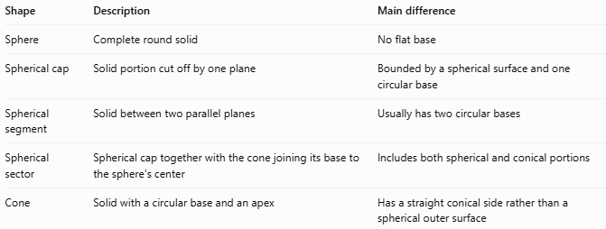
Shape | Description | Main difference
Sphere | Complete round solid | No flat base
Spherical cap | Solid portion cut off by one plane | Bounded by a spherical surface and one circular base
Spherical segment | Solid between two parallel planes | Usually has two circular bases
Spherical sector | Spherical cap together with the cone joining its base to the sphere's center | Includes both spherical and conical portions
Cone | Solid with a circular base and an apex | Has a straight conical side rather than a spherical outer surface

Applications
# Source: AI Source: Provided by: [Data Path: Persons Table -> ID Column: 1, Name_En Column: Motasem Essam] -> From: [ChatGPT] on [7/25/2026]
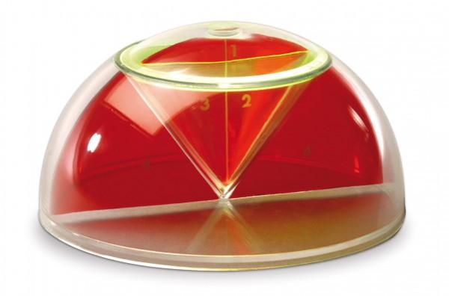
Geometry and Mathematics
Spherical sectors help illustrate how spherical and conical regions combine to form a three-dimensional solid.
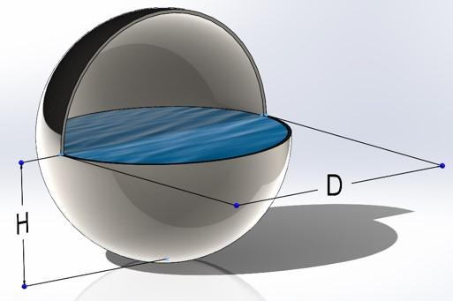
Engineering
Related spherical-sector calculations can help model portions of spherical vessels and rounded components.
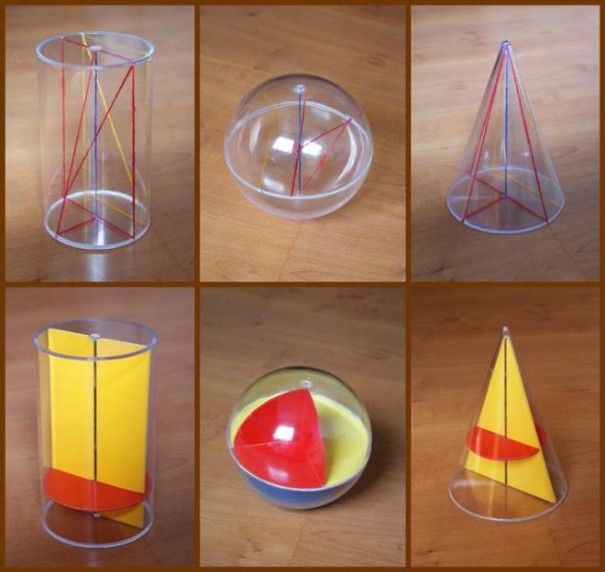
Solid Geometry Education
The shape demonstrates the relationship between a sphere, spherical cap, cone, surface area, and volume.

Key Points
# Source: AI Source: Provided by: [Data Path: Persons Table -> ID Column: 1, Name_En Column: Motasem Essam] -> From: [ChatGPT] on [7/25/2026]
- A spherical sector consists of a spherical cap and its associated cone.
- The cone's apex is at the center of the original sphere.
- The circular base radius is $a=\sqrt{2Rh-h^{2}}$.
- The volume is $V=\frac{2}{3}πR^{2}h$.
- The curved spherical area is $A_{c}=2πRh$.
- A spherical sector is different from a spherical segment, which lies between two parallel planes.
- A hemisphere is the special case $h=R$.

Conclusion
# Source: AI Source: Provided by: [Data Path: Persons Table -> ID Column: 1, Name_En Column: Motasem Essam] -> From: [ChatGPT] on [7/25/2026]
A spherical sector is a solid associated with a spherical cap and a cone extending from the cap's circular boundary to the sphere's center. It combines curved spherical geometry with a conical region, making it useful for studying three-dimensional volume and surface relationships.

